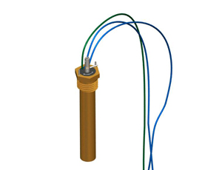
Turning the Setscrew counter-clockwise turns the heater up. The thermostat comes from the Factory set at 40 degrees. This Thermostat works well for Customers that want the entire bowl ice-free, although it will use more electricity when set higher than the Factory setting.

